Football Kamp 2019  Because of YOU we were able to host a football Kamp where we:  - CHANGE THE EVIRONMENT  - DEFINE THE CULTURE  - INSPIRE ACTION  Thank you for your support as we SpeakLife into kids through the platform of sports.  Rickey Brady  President of SpeakLife | SpeakLife Football Kamp  Effort – Attitude - Sportsmanship  The influencers are what ultimately drive success or failure. This Kamp was a huge success because of those that invest time, energy and resources. SpeakLife coaches on backrow: PJ Mills, Aaron Parker, Chris Chamberlain, Rickey & Ethan Brady, Shawn Mills, Ben Matthews, Jared Allen, Billy Bajema.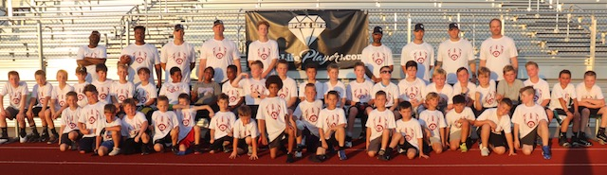  Grade School SpeakLife Football Kamp  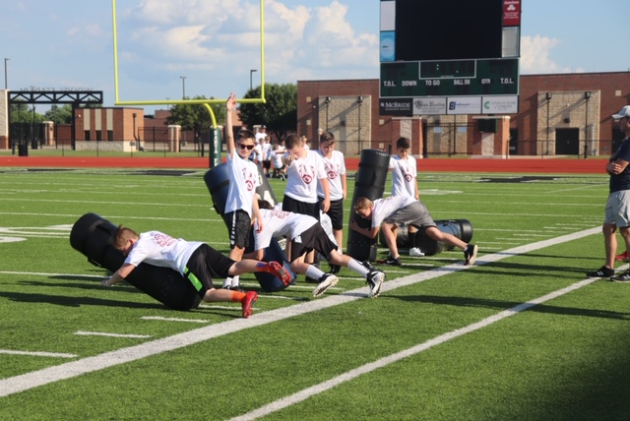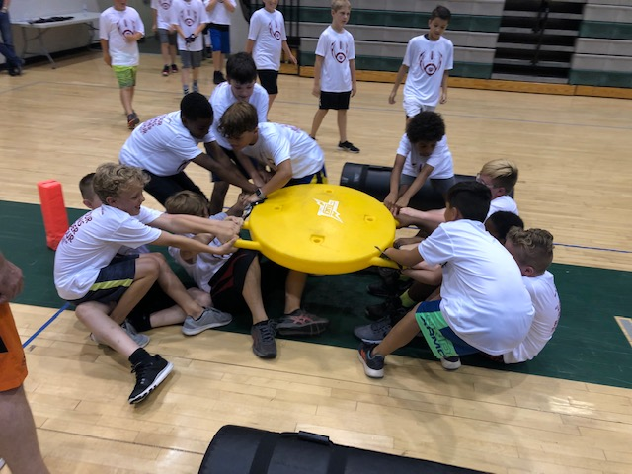  Learning to tackle with head up Weather couldn’t keep us from competing  This Kamp is designed to SpeakLife into kids through the platform of football. We intentionally implement part of the M.A.P.S program so every child recognizes the best form of motivation, which is encouragement. The Message is to dominate the areas of effort, attitude and sportsmanship. The Action at this Kamp is to Change the Environment. We do this with the SpeakLife coaches’ ability to encourage through verbal communication and recognition of good attitudes. The Promise, which is a quote on the back of their Kamp t-shirt, is “Let your actions be louder than your mouth.” The Skill learned from MAPS#1 is to RESPOND instead of re-act. We focused primarily on skill positions and created a high energy fun environment where I can say with confidence, they learned a lot more than just football. I truly appreciate all you that make this possible. Every donation makes an impact and those that have made the monthly commitment I can’t begin to tell you how significant your role is to the vision.

